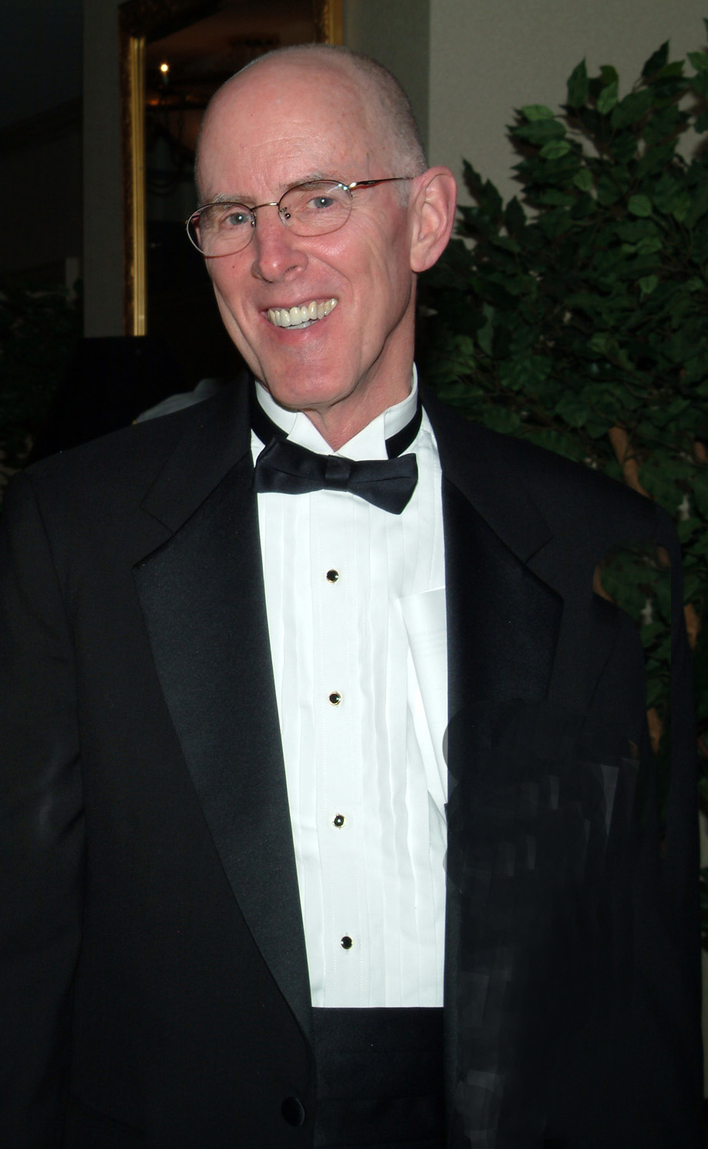

Thomas H. Claus, Ph.D.

Thomas Harrison Claus, Ph.D., world published research scientist and professional leader of team-based projects in the area of type 2 diabetes and obesity, Dr. Claus received his Ph.D. in Biochemistry from the University of Illinois at Chicago. He taught at Vanderbilt University, and spent most of his career in the pharmaceutical industry working to discover new drugs for the treatment of type 2 diabetes and obesity. Tom developed FDA approved drugs for type 2 diabetes receiving Special Recognition Award for “Champion of Change’ from V.P., Research. Now as a scientific specialist, he writes and edits publication manuscripts, slide kits, monographs, newsletters and congress/exhibit materials based on research conducted in specialized areas of medical science.

Tom’s family came to the United States from Wales, England in the 17th century where they founded cities, towns and churches. On his maternal side, Richard Harrison, Sr. founded Branford, Connecticut in 1644, and his son Richard Harrison II, founded Newark and other New Jersey cities. His maternal grandfather established the Skagway Presbyterian Church in Alaska and Seattle Presbyterian in Seattle and wrote a number of bible commentaries. His father, Wilbur Claus discovered Cheerios and other memorable foods while at General Mills and Carnation, while his uncle was awarded Professor of the Century by Wheaton College in Wheaton, Illinois as he turned 100 years of age.

