PRESS RELEASE FOR IMMEDIATE RELEASE
"Art Students Honor Their Heroes"
2020 ART EVENTS JUNE 14 - JULY 2
SPONSORED BY THE CONNECTICUT SOCIETY OF PORTRAIT ARISTS http://www.CSOPA.org
Contacts: Jeanine C. Jackson, CSOPA President: email csocietyopa@aol.com; 203-856-4713
and Bridget Grady email: bgrady@bridgetgrady.com
Photos provided with permission to publish in association with this press release. Additional permissions available by written request.
==================================================
Art Students Honor Their Heroes
Once it became apparent that schools would remain closed this spring, art teacher Bridget Grady grew concerned for her students - especially the seniors at Northwest Regional 7 high school in New Hartford. At time when they should be able to celebrate their final year and bright futures, many struggle with isolation and uncertainty. As Ms. Grady looked for ways to lift their spirits, The Connecticut Society of Portrait Artists (CSOPA) in Greenwich announced a members-only online event, "Faces of Pandemic Front Lines" (FPFL). She enrolled five of her most promising students to create original art paintings or drawings of people in essential services that inspire them. Their impressive work and extraordinary stories can be viewed in the online gallery along with fifteen hero portraits by professional artists. The Zoom Reception June 14 is followed by a window display June 19 - July 2 in collaboration with Stamford Downtown at 172 Bedford Street. "It is a privilege for these young artists to be part of such an important CSOPA event," says Ms. Grady. CSOPA President, Jeanine Jackson adds, "Bridget's students put their hearts and talent into this historic project . We are very proud to have them with CSOPA and to honor their heroes."

========= Below taken from Online Gallery======
FPFL STUDENT WORK
SPONSORED BY ART TEACHER, BRIDGET GRADY
​Five selected Northwestern Regional 7 High School Seniors share portraits, stories about their heroes, and what life for them has been like during this pandemic.
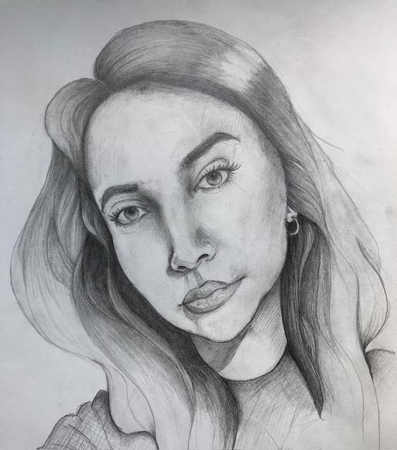
==================================
Nicole Lodovico by MADELINE FAITH GIACONID
Portrait Title: Nicole
​My subject is Nicole Lodovico. Nicole and I are not the closest of friends, but over the last year working alongside her as a student council officer I have come to know her as a kind and enthusiastic person with an outgoing personality that makes her well-loved in our class. During the pandemic, she continued working her job at a grocery store. Months ago, when the action against the pandemic was just beginning, I remember her telling us about having to wear gloves and masks at work as the anxiety rose and her shifts grew longer. Nicole has also worked to ease the disappointment of her fellow graduating seniors by editing a video for National Decision Day, an exciting part of senior year that we missed due to the pandemic.
About school: The impact of the coronavirus on my senior year of high school has been massive and often difficult to cope with. The knowledge that I will never see my classmates in the hallways or wave hello to my teachers again has been hard to process. Not being able to perform my final show with the theater program was one of the biggest punches to the gut. However, I have tried to remember that everything that has happened is for the best, and there's ultimately nothing I can do to change it. I'm grateful to have the support of friends, family, and teachers, which I know many people are lacking in this time. Despite everything, at the end of the day, I know I'm one of the lucky ones.

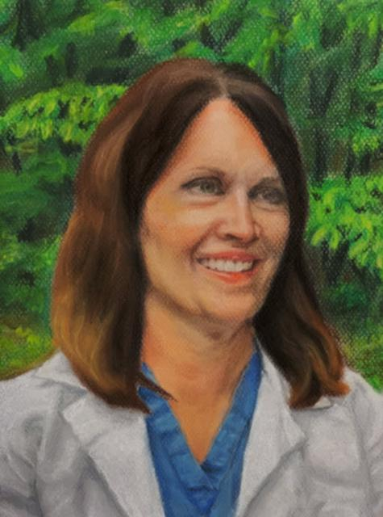
Kim Keegan by CASIDHE HUGHES
Kim Keegan is one of the most magnificent, caring, and selfless people I have ever met. She is a crucial member of the brilliant team of nurses at Hartford Hospital, helping to save the lives of many. Her glow of compassion does not cease with the end of the workday, as she is also the patient and hardworking single mother of 4. She has a deep understanding of her patients and their personal importance, as she has battled Lyme Disease and leukemia within her only family. Kim sees the impact this can have on families and pours the same care into her patients as if they were her own children.

Quarantine and online school has been full of difficulties and growth. Through having virtually none, I have come to realize the huge importance of human contact and connection. I am now missing things that I previously took for granted...yes, that includes school, and it makes me realize just how good our life here on earth really is. Although the situation is not ideal, the free time Covid 19 has so graciously granted us has given me the opportunity to work on myself and the things I am passionate about, including my artwork. Never before have I had the opportunity to spend so much time brainstorming and creating without the distraction of stress drawing me away. I am so thankful for this opportunity to show my appreciation for the front line workers who are risking their own well-being in attempt to combat this heartbreaking and difficult disease. I, like many, hope for this crisis to resolve as soon and safely as possible, so the hardships can become part of the past, but I am positive that the effort and care of the brave workers will never be forgotten.

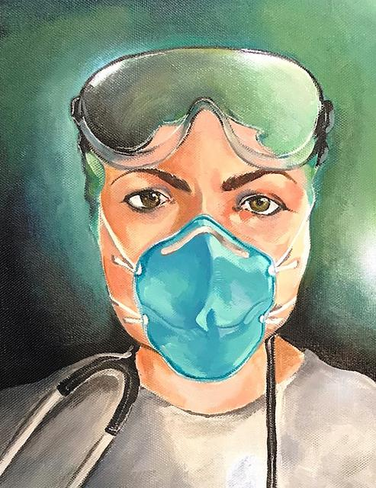
Amy Koch by CLARA KOCH
Portrait Title: Stand Behind Me
Medium: Acrylic Paint
FPFL Story:
The front-line hero I'm choosing to paint is my mom, Amy Koch. She had been an EMT for many years before she decided to pursue her dream of becoming an emergency department nurse. She graduated from Northwestern Connecticut Community College as an RN. She now works at Charlotte Hungerford Hospital in the Emergency Room and has worked on several COVID-19 units in the hospital.
She also continues to volunteer her time during the pandemic at a local Ambulance Association. In her free time she works towards getting her masters in Nursing Education. Despite the pandemic, she takes amazing care of me and my sister as a single parent. She goes to work every day and continues to take care of people who are suffering. I am painting her because she is the bravest person I know.

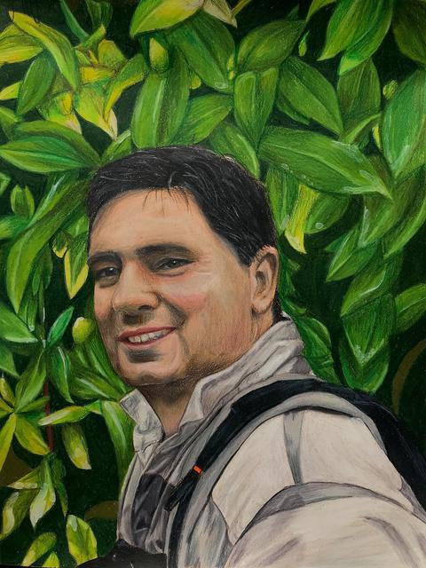
Big Kev by GEORGIA HALEY MILLER
“Big Kev”, or more commonly known as Kevin Harwood, is the father of one of my very close friends. Typically an ER nurse; he was one of the first people to take care of Covid-19 patients at Charlotte Hungerford. He has quite the family with six children to take care of on top of being a nurse during these troubling times. My heart goes out to him and his strong will and passion to help people whether it be family or patients.

School has been an interesting experience due to Covid-19. Online school is a completely different experience than in class. Online, It is a lot less teaching and a lot more filler activities. It is hard to teach yourself online; and almost impossible to socialize with peers. Which is very important to do face-to-face these days. It is difficult to learn art online, so you have to have a lot of trust in your ability to draw without the eye of another person to help. It is definitely a learning experience

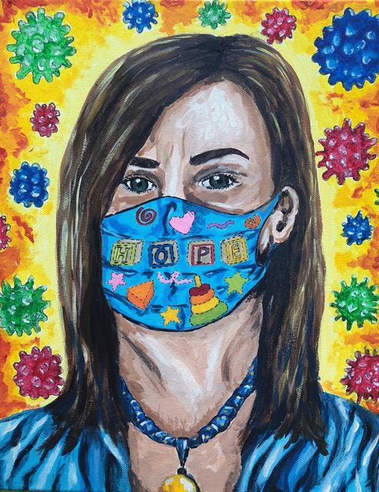
Elizabeth Marek by CAROLYN MAREK
Portrait Title: Care for Me
FPFL Story:
My front-line hero is my mother, Elizabeth Marek. Every day she goes out into this uncertain world. All of her life she has been an educator and passionate about helping children. She works at an early childhood education school, and continues to after the Governor of Connecticut deemed childcare centers as essential, and even went as far as saying that childcare is the backbone of getting through this pandemic. Without care of their children, healthcare workers, first responders, and needed workers would not be able to fight the pandemic. This past year I lost my father, and my mother is my anchor. I know my mother has anxiety about the severity of this virus, and the possibility of contracting it, and about me if she did not survive it. I love my mother more than anything else in the world, and although I fear for her every day, I know that it is necessary that she goes to work to help others.

