PRESS RELEASE: FOR IMMEDIATE RELEASE DRAFT 5
Date: December 20, 2018
Subject: FACE TIME Portrait Exhibit and Events
Location: Greenwich Arts Council, Bendheim Gallery and Meeting Room, 299 Greenwich Avenue, Greenwich, CT 06830; 203-862-6750
Duration: January 13 - February 7, 2019
Cost: Free and Open to the Public Images provided with artist permissions to print.
Contact: Jeanine C. Jackson, CSOPA Founder and President; csocietyopa@aol.com; 203-856-4713

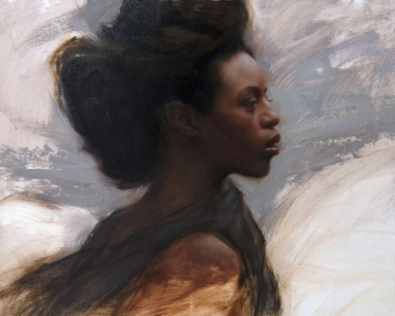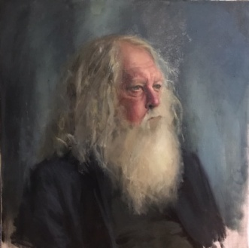
Profile by Grace Mehan DeVito inspired by the work of Sue Bryce Zarzan by Pamela Ackley

FACE TIME: Classic Portraiture in a Digital Age will be at the Bendheim Gallery, 299 Greenwich Avenue, from January 13 through February 7, 2019. Despite ubiquitous digital photography and selfies, the demand for the work of classically trained portrait artists is increasing. This curated exhibition by The Connecticut Society of Portrait Artists and The Greenwich Arts Council demonstrates why portraiture remains a popular genre. With a large selection of paintings, drawings, and sculptures, this exhibition reveals the variety of styles, media, and approaches conveyed by the contemporary portrait artist.
Please join us for the opening on Sunday January 13, with an interactive "Meet the Masters" Gallery walk. Special guests including Silvermine Arts Center Instructor, Eddie Nino, from 2-2:30. An elegant awards reception follows with refreshments and a live jazz performance by Roni GZB, Jr. from 2:30-4. During the reception, acclaimed portraitist Grace Mehan DeVito will present a live demonstration of painting from life, with guest model, Marcia O'Kane, CEO and President of The Greenwich Chamber of Commerce. FREE and Open to the Public. (Snow date January 20)

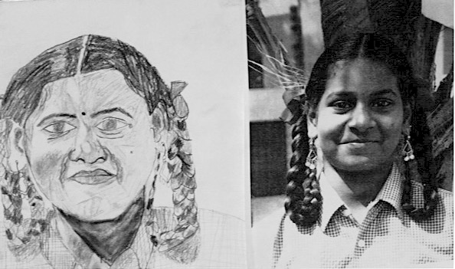
There is a special Children's Portrait Workshop for ages 8-18 on Saturday, January 26 from 2-3:30, with art educators Deborah Howland-Murray and ShawnaLee Kwashnak. This is a rare opportunity for youth to practice their observation skills while learning the valued art of portraiture from skilled professionals in the field. Pre-registration is necessary to secure limited space and please note the $5 workshop materials fee. (Snow date February 2, 3:30-5)
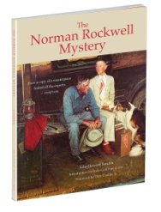
The Norman Rockwell Mystery
Saturday afternoon February 2, from 2 to 3 Presidential Portraitist John Howard Sanden will premiere Unmasking One of the Great Capers in the History of Art Deception.
This fully illustrated slideshow tells of a unique episode in the lively history of American illustration art. Free admission, however pre-registration is required.

Gallery schedule, snow dates, event pre-registrations, and additional Face Time information is available on csopa.org and greenwicharts.org.

Children's Portrait Workshop photo by Deb Howland-Murray
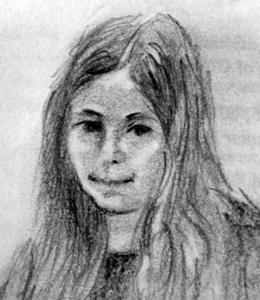 Anna by ShawnaLee Kwashnak

CHILDREN'S PORTRAIT WORKSHOP DETAILED RELEASE:
January 26, 2019, 2-3:30 - Children's Portrait Workshop at The Greenwich Arts Council, 299 Greenwich Avenue.
The Connecticut Society of Portrait Artists and The Greenwich Arts Council present a unique opportunity for youth ages 8-18 to learn and experience the art of portraiture. Young people are invited to attend a free workshop to be held on Saturday, January 26th from 2-3:30 at the GAC. (Snow date February 2, 3:30-5.)
This workshop will be co-taught by portrait artists Deborah Howland-Murray and ShawnaLee Kwashnak (image). Lessons cover proportions along with valuable insider tips for observing and sketching the portrait.
Participants are asked to bring with them an 8 x 10 black and white photograph head shot of themselves.
Free; however , a $5 materials fee and pre-registration are required to secure limited space on csopa.org and greenwicharts.org.

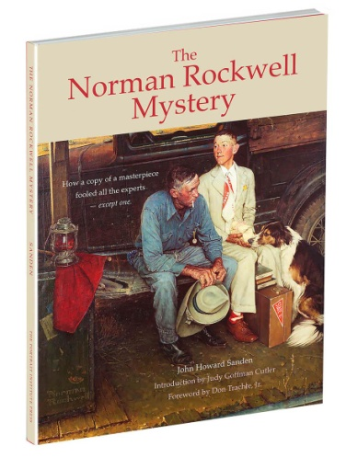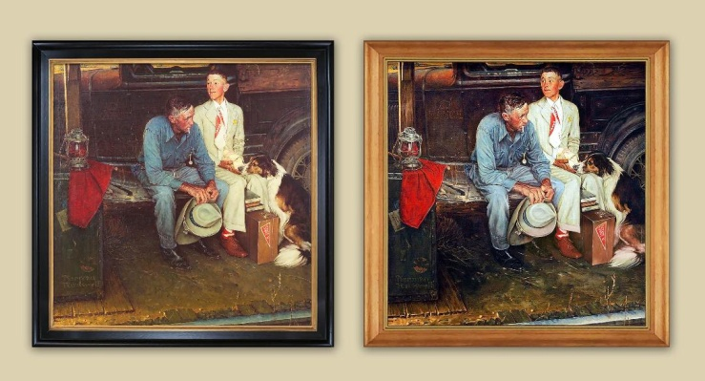
The Norman Rockwell Mystery Book Which one is the fake?

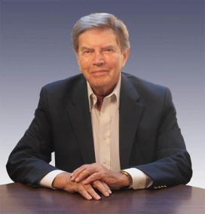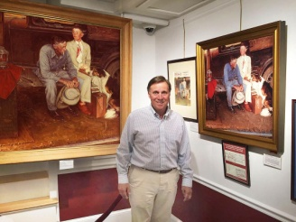
John Howard Sanden Don Trachte, son of the artist who painted the replica

JOHN HOWARD SANDEN DETAILED PRESS RELEASE:
The Norman Rockwell Mystery
Unmasking One of the Great Capers in the History of Art Deception
Saturday, February 2, 2019 from 2-3 Presidential Portraitist John Howard Sanden will deliver a special presentation at the Greenwich Arts Council, 299 Greenwich Avenue. This fully illustrated slideshow tells of a unique episode in the lively history of American illustration art — a venture into deception that, for its sheer success, may be without parallel in all of art history. The story involves a masterpiece by America’s favorite artist — the beloved illustrator Norman Rockwell (1894–1978) — and a painted replica of Rockwell’s great picture that, for a period of three years, completely fooled the museum experts, the publishers of scholarly journals, and the famous artist’s devoted public.
The triumphant success of the hoax was almost total. Even the owners of the great painting, who had cherished it in their home for forty years, were unaware that, when they allowed the painting to be included in an important national exhibition, they were exhibiting a fraud.
You will see John Sanden’s unique role in solving the mystery, watch as the great painting is finally found (after being hidden away for more than thirty years), and sold at Sotheby’s for fifteen million dollars.
Q&A follows with Mr. Sanden and special guest Don Trachte, son of the artist who painted the replica. Free admission, however pre-registration is required on csopa.org and greenwicharts.org.

SHORT RELEASES:
January 13, 2019 - FACE TIME: Classic Portraiture in a Digital Age at the Bendheim Gallery , 299 Greenwich Avenue . "Meet the Masters" and gallery walk 2-2:30, opening reception, live portrait demo, and jazz piano 2:30-4. Free admission. Exhibition on view through February 7, 2019. Info on csopa.org and greenwicharts.org.

January 26, 2019, 2-3:30 - Children's Portrait Workshop for ages 8-18 at The Greenwich Arts Council 299 Greenwich Avenue. $5 materials fee and pre-registration are required to secure limited space. Info on csopa.org and greenwicharts.org.

February 2, 2019, 2-3 at The Greenwich Arts Council 299 Greenwich Avenue, Presidential Portraitist John Howard Sanden presents The Norman Rockwell Mystery Unmasking One of the Great Capers in the History of Art Deception. Free. Pre-registration required to secure limited space. Info on csopa.org and greenwicharts.org.

9 images attached with permission to print with these press releases as indicated above:
Profile by Grace Mehan DeVito inspired by the work of Sue Bryce
Zarzan by Pamela Ackley
Children's Portrait Workshop Sample photos by Deb Howland Murray
Anna by ShawnaLee Kwashnak
John Howard Sanden
The Norman Rockwell Mystery Book
Which one is the fake?
John Howard Sanden
Don Trachte
Face Time Exhibition 42 Participating Artists
Pamela | Ackley | New Canaan | CT
Alfonsina | Betancourt | Norwalk | CT
Shay | Blum | Ocean | NJ
Paige | Bradley | Riverside | CT
Lisa | Burns | Wilton | CT
Wende | Caporale | North Salem | NY
Anastasiya | Chybireva-Fender | Flower Mound | TX
Michel | Delafontaine | Rye Brook | NY
Connie | Freid | Yonkers | NY
Letizia | Gentile | Larchmont | NY
Cynthia | Gillette | Woodbury | CT
Scott | Glaser | Westport | CT
Joan Elizabeth | Goodman | New York | NY
Colleen | Hains | Norwalk | CT
Deborah | Howland-Murray | Westport | CT
Jeanine | Jackson | Greenwich | CT
Shiva | Jlayer | New Rochelle | NY
Tricia | Kaman | Chagrin Falls | OH
Flladi | KULLA | Middlebury | CT
Shawnalee | Kwashnak | Middlebury | CT
Liz Jorg | Masi | Smithtown | NY
Barbara | Mathis | Stamford | CT
Luis de | Mena | Rye | NY
Nicole | Moné | Ossining | NY
Steven | Parton | Westport | CT
Alain | Picard | Southbury | CT
Gail | Postal | New York | NY
John | Sanden | Ridgefield | CT
Jill | Sarver | Bridgeport | CT
Peter | Seltzer | Woodbury | CT
Barbara | Simonson | Darien | CT
Nancy | Stember | Norwalk | CT
Joseph | Sundwall | Montgomery | NY
John | Sweeney | Hamden | CT
Candace | Taubner | Pelham Manor | NY
Kathleen | Ullman | Westhampton | NY
Cindy | Wagner | Weston | CT
Robert | Whelan | Valatie | NY
Richard | White | Coventry | CT
Joyce | Zeller | Harrison | NY

